- Create a Flask application with an /api route. When this route is accessed, it should return a JSON list. The data should be stored in a backend file, read from it, and sent as a response.
Firstly I created data.json it acts like backend file .
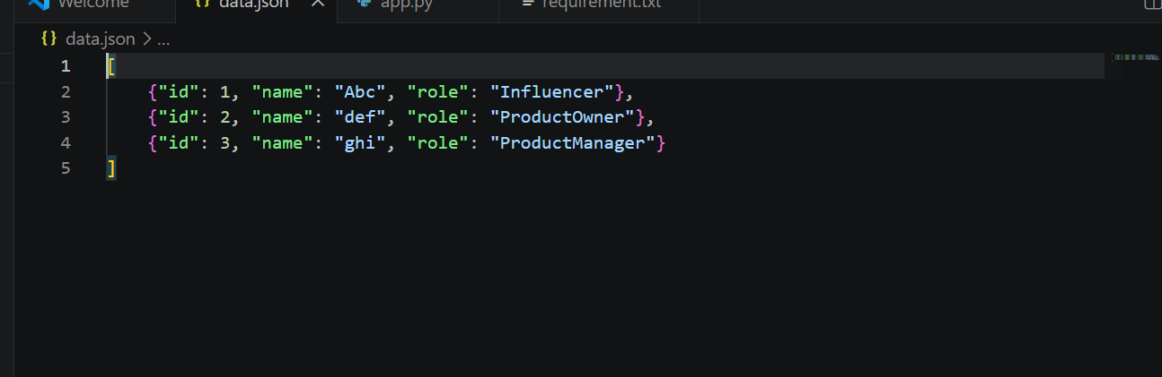
app.py — a Flask app that reads data.json and serves it at /api.
And I install flask and it dependencies .

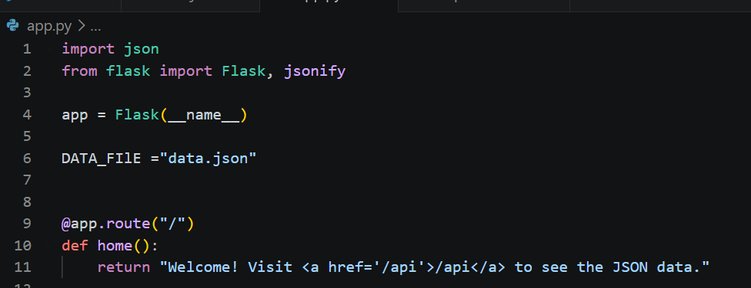
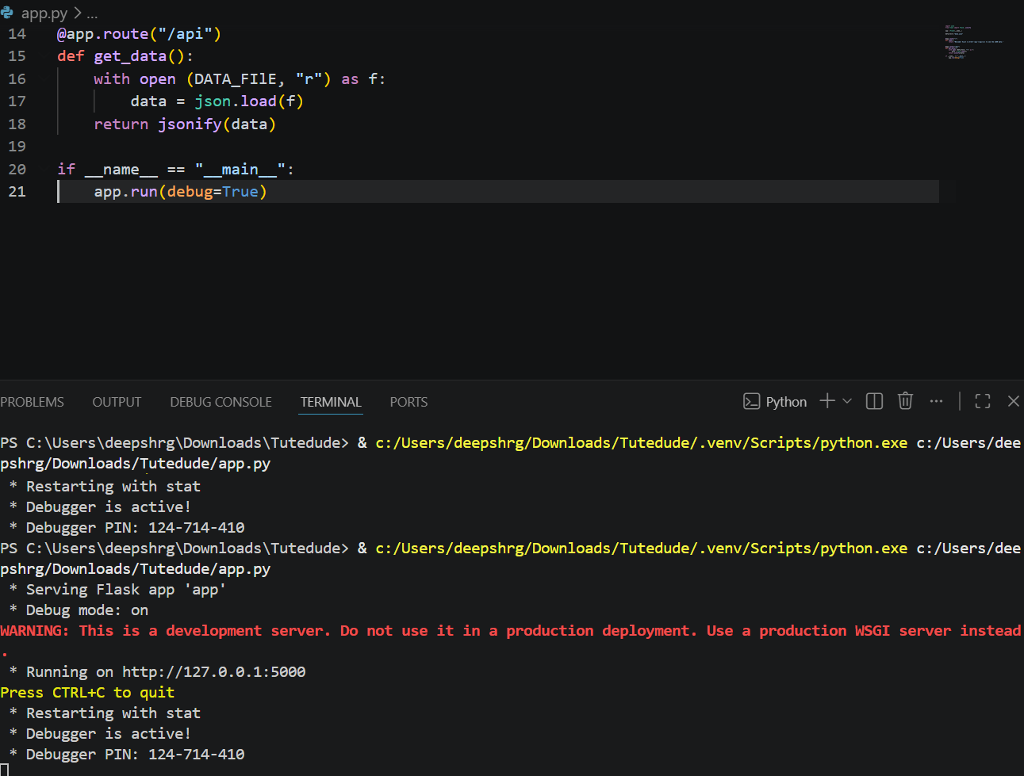.
When we hit the URL it read the data from backend json file and sent us in response /api
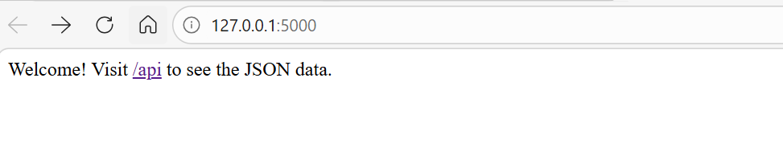
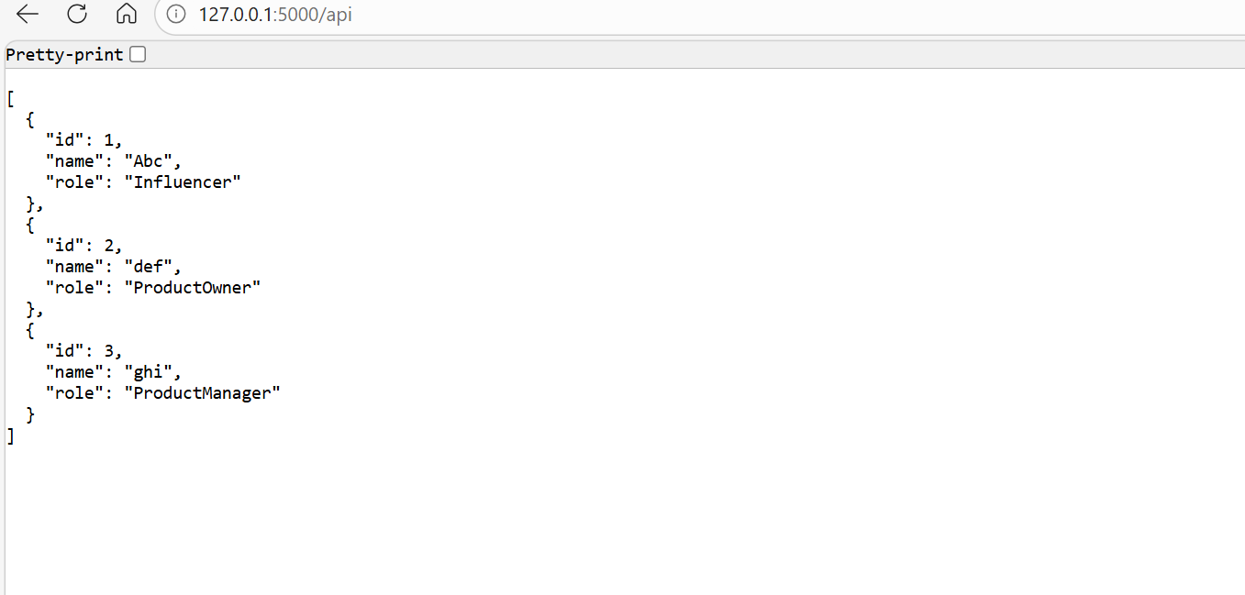
- Create a form on the frontend that, when submitted, inserts data into MongoDB Atlas. Upon successful submission, the user should be redirected to another page displaying the message "Data submitted successfully". If there's an error during submission, display the error on the same page without redirection.

Created 3 files :
app.py — The Backend (Flask + PyMongo)
templates/form.html — The Form Page
templates/success.html — The Success Page (redirect target)

after that I Install dependencies, created free tier mongodb database and then make the connection to MongoDB Atlas connection string.
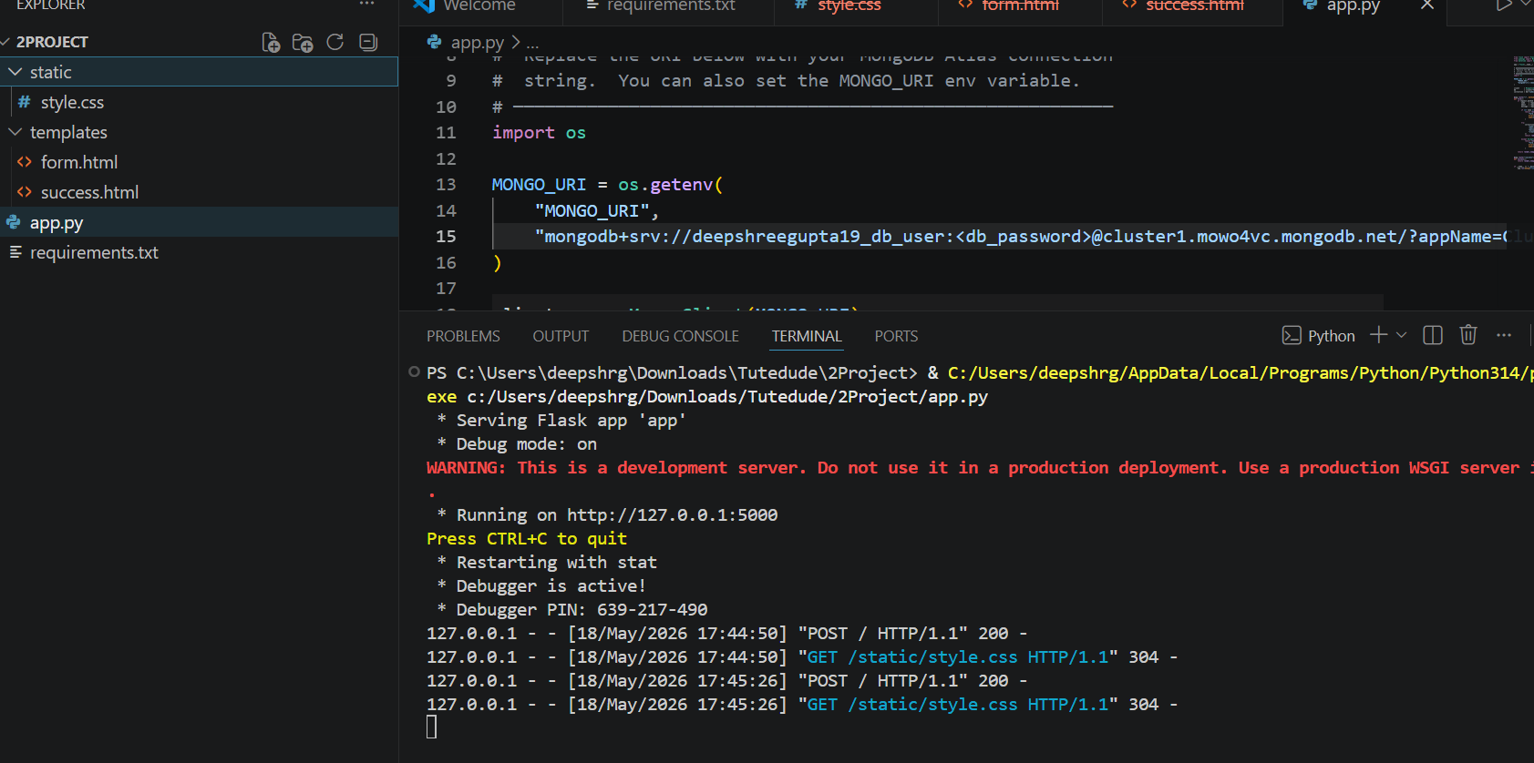
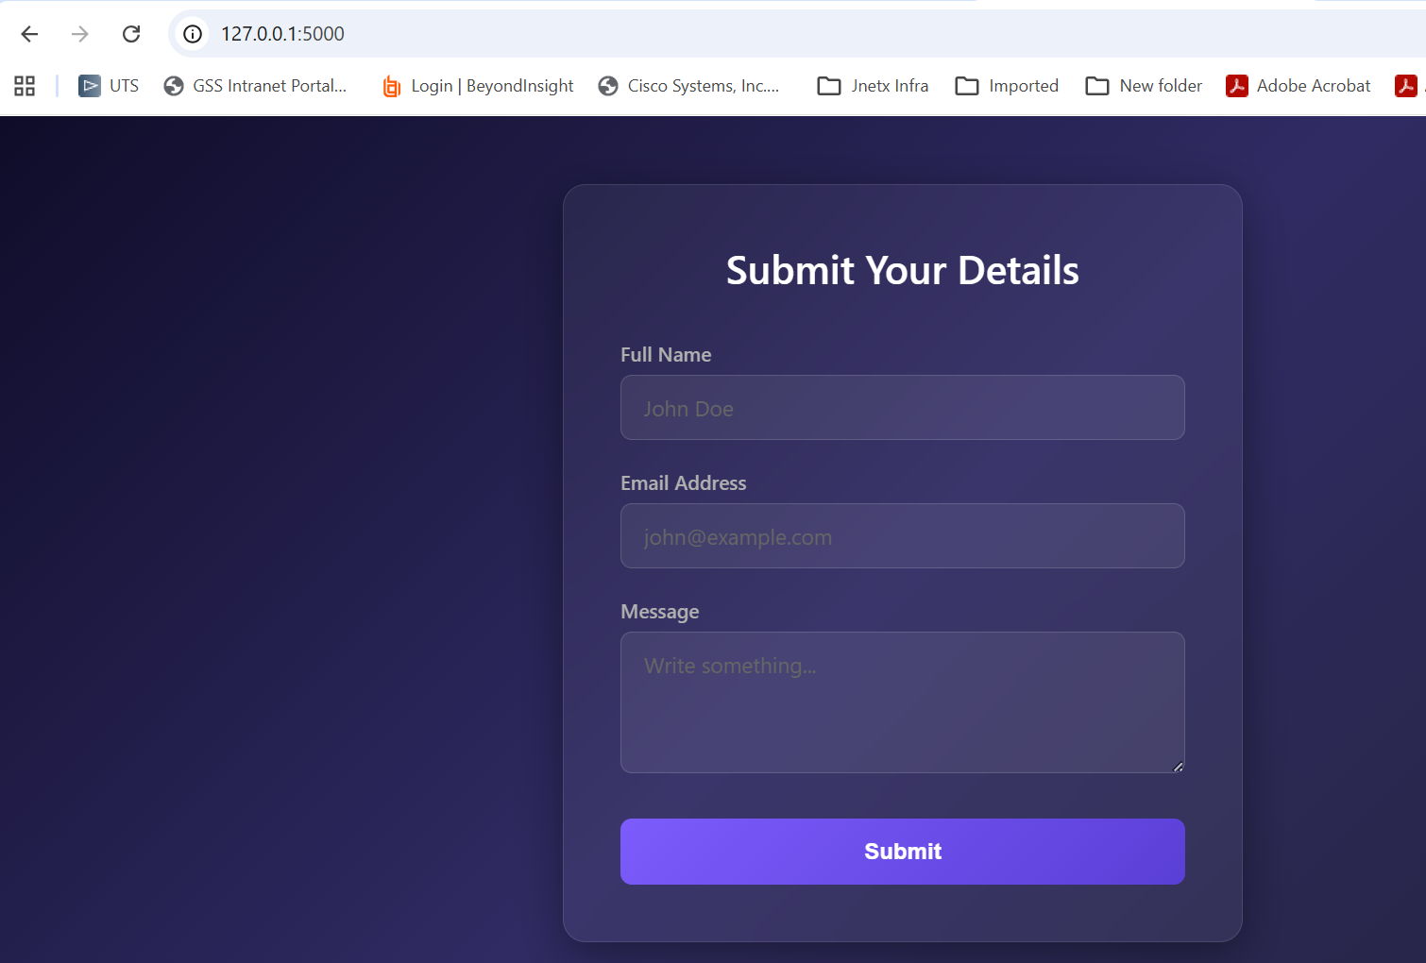

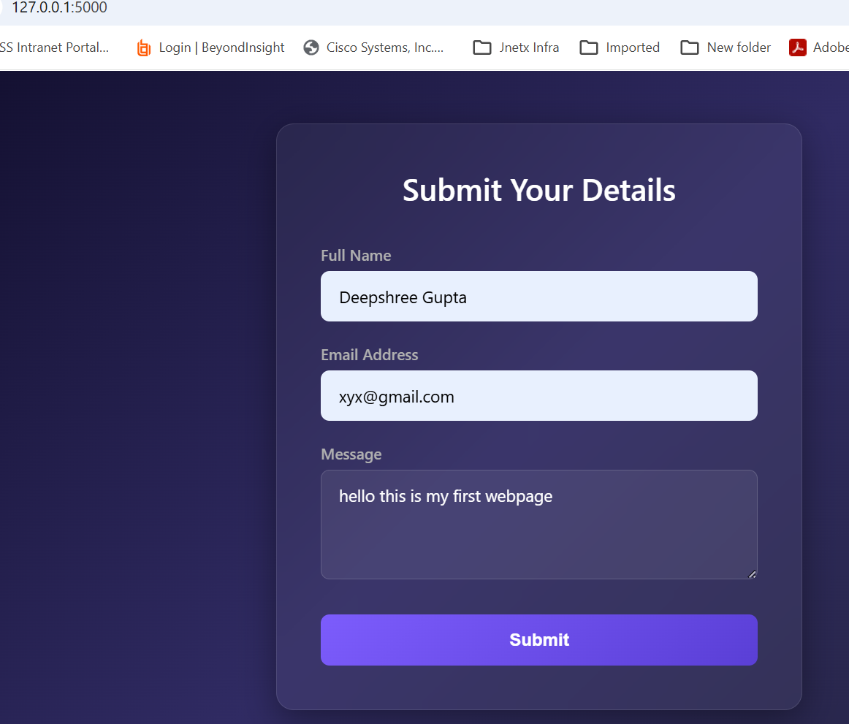

Submission Guidelines -: Attach Screenshots or command along with explanation and submit in doc(google doc or microsoft doc) format also attach github repo link

